Nane: D.Padma Sree
Course code:CSA0618
Course :DAA
EX 16:
def sort_list(arr):
return sorted(arr)

print(sort_list([]))
print(sort_list([1]))
print(sort_list([7, 7, 7, 7]))
print(sort_list([-5, -1, -3, -2, -4]))
OUTPUT:
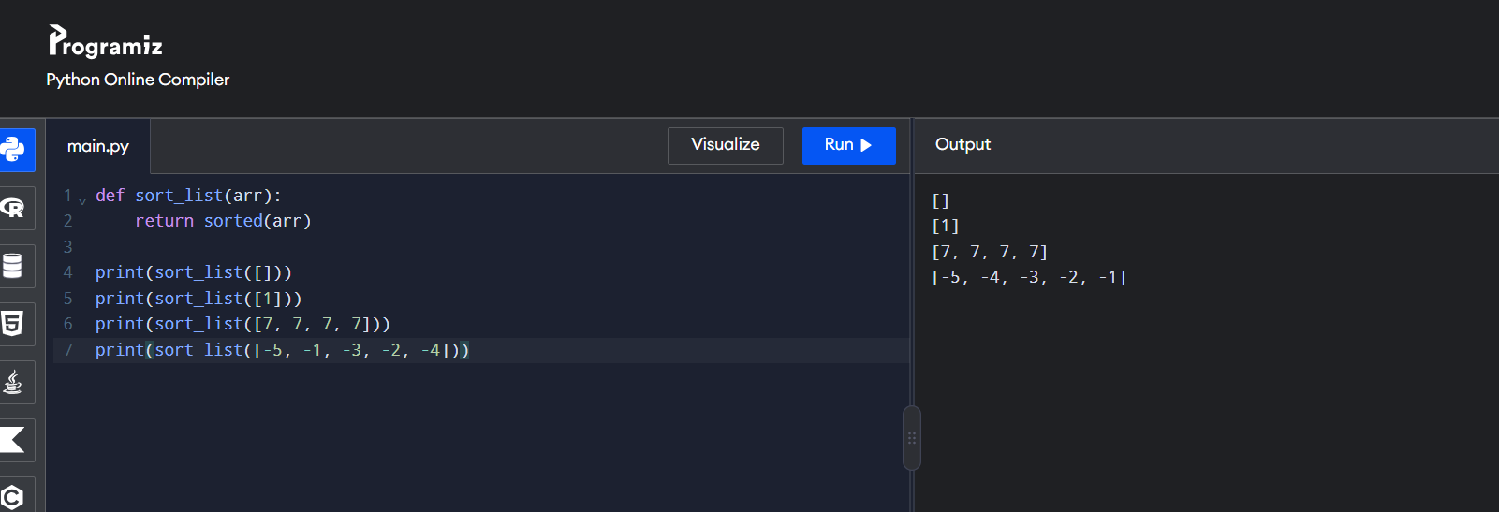
EX 17:
def selection_sort(arr):
for i in range(len(arr)):
m = i
for j in range(i + 1, len(arr)):
if arr[j] < arr[m]:
m = j
arr[i], arr[m] = arr[m], arr[i]
return arr

print(selection_sort([5, 2, 9, 1, 5, 6]))
print(selection_sort([10, 8, 6, 4, 2]))
print(selection_sort([1, 2, 3, 4, 5]))
OUTPUT:
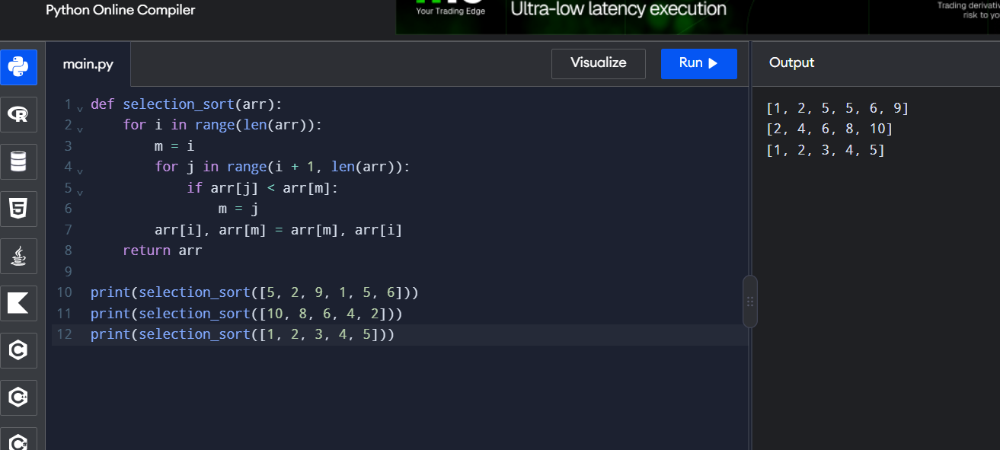
EX 18:
def bubble_sort(arr):
n = len(arr)
for i in range(n):
swapped = False
for j in range(n - i - 1):
if arr[j] > arr[j + 1]:
arr[j], arr[j + 1] = arr[j + 1], arr[j]
swapped = True
if not swapped:
break
return arr

print(bubble_sort([64, 25, 12, 22, 11]))
print(bubble_sort([29, 10, 14, 37, 13]))
print(bubble_sort([3, 5, 2, 1, 4]))
print(bubble_sort([1, 2, 3, 4, 5]))
print(bubble_sort([5, 4, 3, 2, 1]))

OUTPUT:
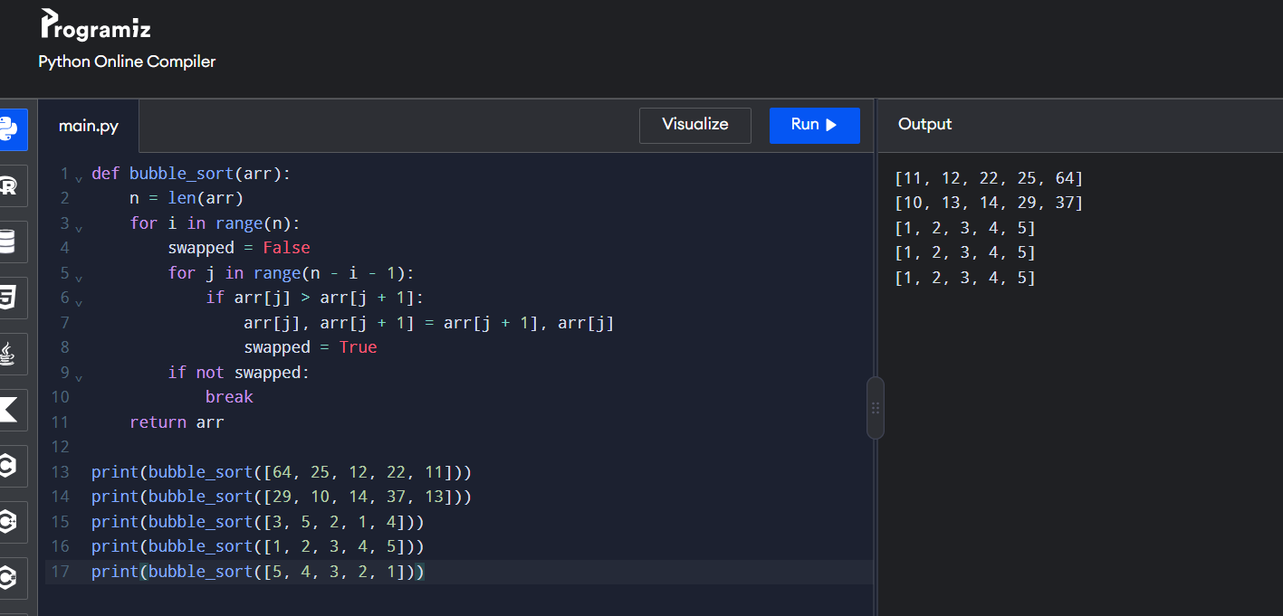
EX 19:
def insertion_sort(arr):
for i in range(1, len(arr)):
key = arr[i]
j = i - 1
while j >= 0 and arr[j] > key:
arr[j + 1] = arr[j]
j -= 1
arr[j + 1] = key
return arr
print(insertion_sort([3, 1, 4, 1, 5, 9, 2, 6, 5, 3]))
print(insertion_sort([5, 5, 5, 5, 5]))
print(insertion_sort([2, 3, 1, 3, 2, 1, 1, 3]))
OUTPUT:
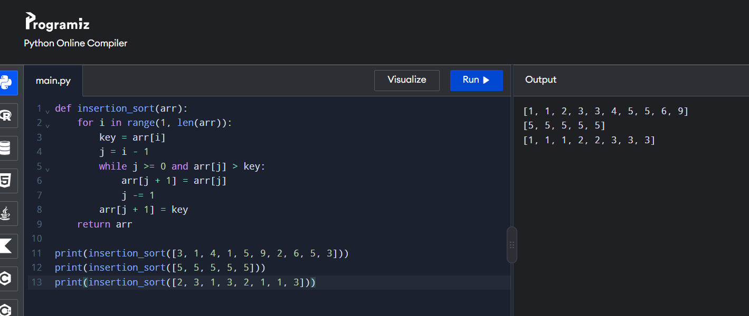
EX 20:
def findKthPositive(arr, k):
missing = 0
num = 1

while True:
if num not in arr:
missing += 1
if missing == k:
return num
num += 1
print(findKthPositive([2, 3, 4, 7, 11], 5))
print(findKthPositive([1, 2, 3, 4], 2))
OUTPUT:
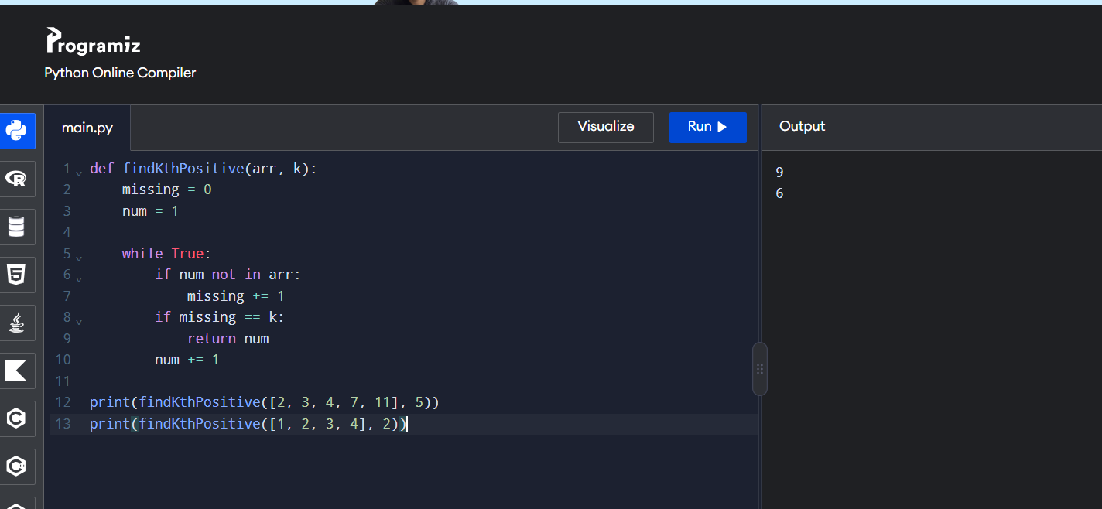
EX 21:
def findPeakElement(nums):
l, r = 0, len(nums) - 1
while l < r:
m = (l + r) // 2
if nums[m] < nums[m + 1]:
l = m + 1
else:
r = m
return l

print(findPeakElement([1, 2, 3, 1]))
print(findPeakElement([1, 2, 1, 3, 5, 6, 4]))
OUTPUT:
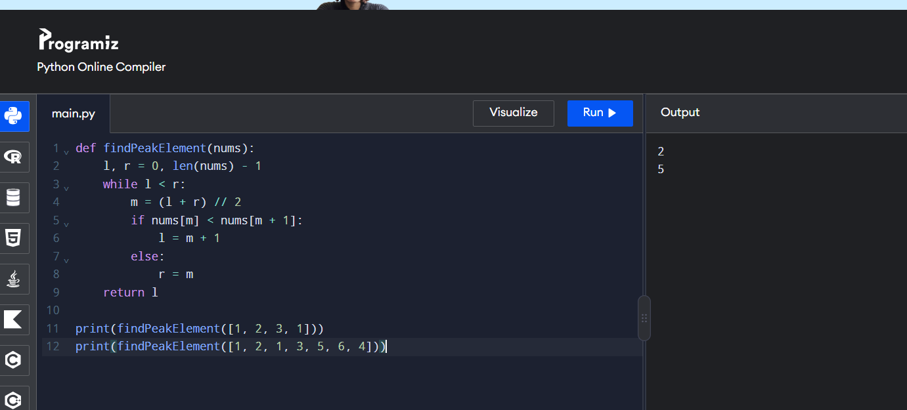
EX 22:
def strStr(haystack, needle):
return haystack.find(needle)

print(strStr("sadbutsad", "sad"))
print(strStr("leetcode", "leeto"))
OUTPUT:
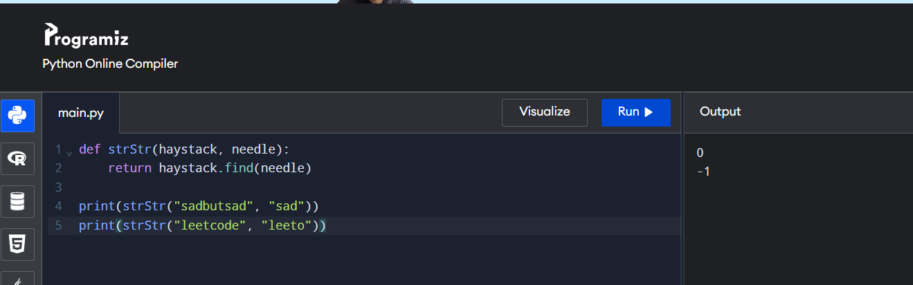

EX 23:
def stringMatching(words):
return [w for w in words if any(w != x and w in x for x in words)]
print(stringMatching(["mass", "as", "hero", "superhero"]))
print(stringMatching(["leetcode", "et", "code"]))
print(stringMatching(["blue", "green", "bu"]))
OUTPUT:
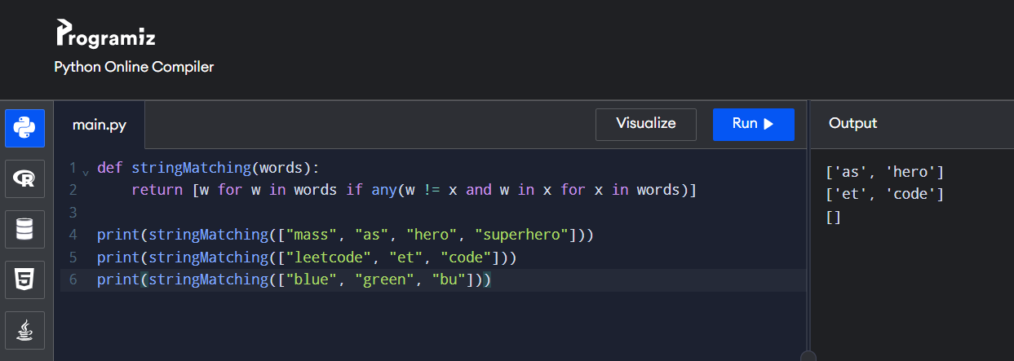
EX 24:
import math

def closest_pair(points):
pair = None
minimum = float('inf')
for i in range(len(points)):
for j in range(i + 1, len(points)):
d = math.dist(points[i], points[j])
if d < minimum:
minimum = d
pair = (points[i], points[j])
return pair, minimum

pair, distance = closest_pair([(1, 2), (4, 5), (7, 8), (3, 1)])
print("Closest pair:", pair[0], "-", pair[1])
print("Minimum distance:", distance)
OUTPUT:
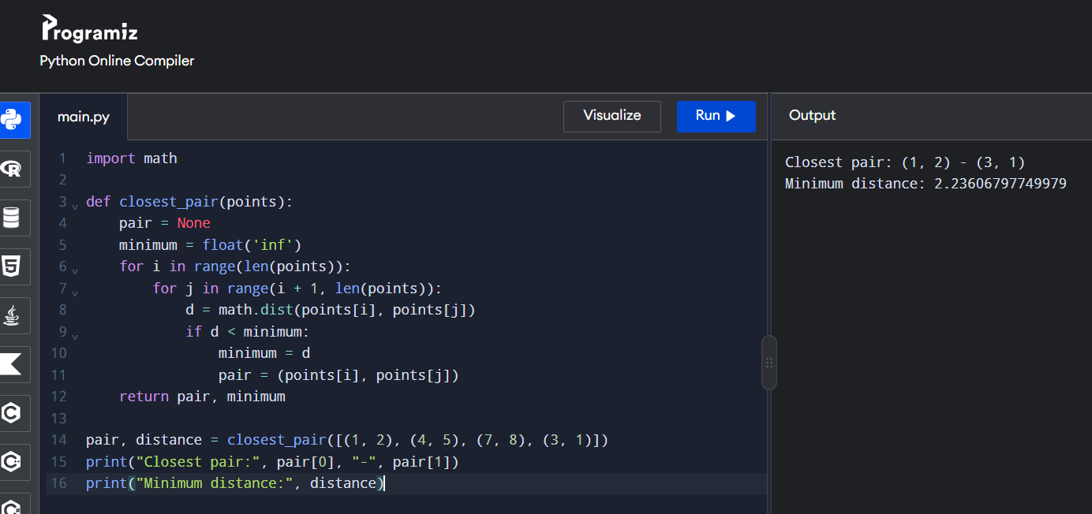
EX 25:
from itertools import combinations

def convex_hull(points):
hull = set()
for a, b in combinations(points, 2):
side = []
for p in points:
cross = (b[0]-a[0])*(p[1]-a[1]) - (b[1]-a[1])*(p[0]-a[0])
side.append(cross)
if all(x >= 0 for x in side) or all(x <= 0 for x in side):
hull.update([a, b])
return sorted(hull)

points = [(10,0), (11,5), (5,3), (9,3.5),
(15,3), (12.5,7), (6,6.5), (7.5,4.5)]

print("Convex Hull:", convex_hull(points))

OUTPUT:
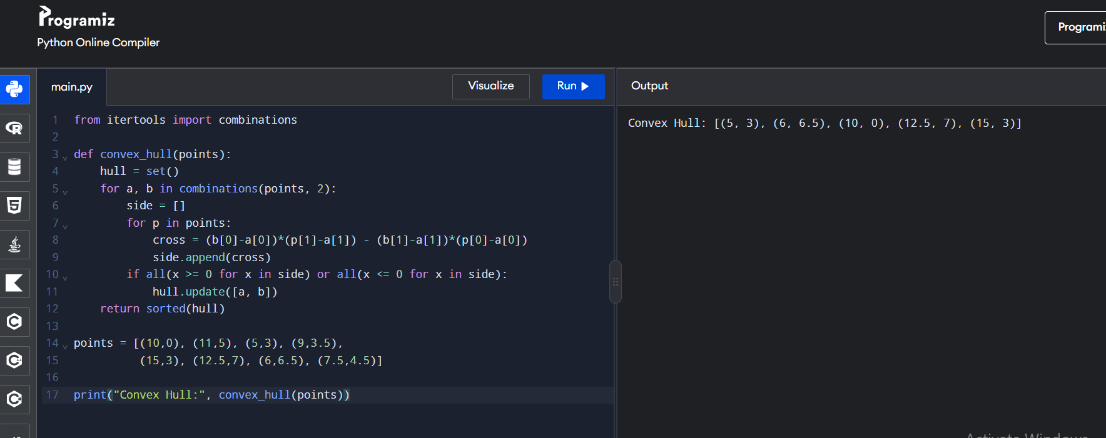
EX 26:
from itertools import combinations

def cross(o, a, b):
return (a[0]-o[0])*(b[1]-o[1]) - (a[1]-o[1])*(b[0]-o[0])

def convex_hull(points):
points = sorted(set(points))
if len(points) <= 1:
return points

lower = []
for p in points:
while len(lower) >= 2 and cross(lower[-2], lower[-1], p) <= 0:
lower.pop()
lower.append(p)

upper = []
for p in reversed(points):
while len(upper) >= 2 and cross(upper[-2], upper[-1], p) <= 0:
upper.pop()
upper.append(p)

return lower[:-1] + upper[:-1]

print("Convex Hull:", convex_hull([(1,1), (4,6), (8,1), (0,0), (3,3)]))
OUTPUT:
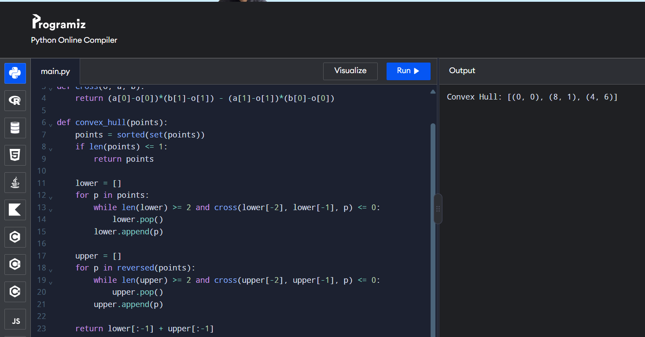
EX 27:
import itertools
import math

def distance(a, b):
return math.dist(a, b)

def tsp(cities):
start = cities[0]
best_path, best_dist = None, float('inf')

for perm in itertools.permutations(cities[1:]):
path = [start] + list(perm) + [start]
d = sum(distance(path[i], path[i+1]) for i in range(len(path)-1))
if d < best_dist:
best_dist, best_path = d, path

return best_dist, best_path

for cities in [
[(1,2), (4,5), (7,1), (3,6)],
[(2,4), (8,1), (1,7), (6,3), (5,9)]
]:
d, path = tsp(cities)
print("Shortest Distance:", d)
print("Shortest Path:", path)
OUTPUT:
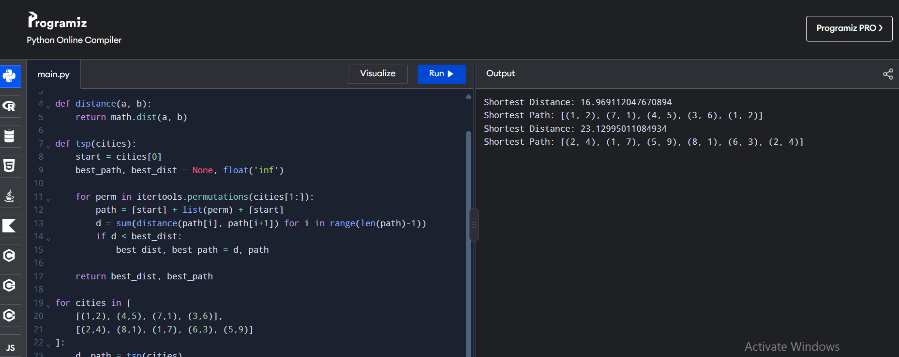
EX 28:
import itertools

def total_cost(assignment, cost_matrix):
return sum(cost_matrix[i][j] for i, j in enumerate(assignment))

def assignment_problem(cost_matrix):
n = len(cost_matrix)
best = min(itertools.permutations(range(n)),
key=lambda a: total_cost(a, cost_matrix))
return best, total_cost(best, cost_matrix)

matrices = [
[[3,10,7], [8,5,12], [4,6,9]],
[[15,9,4], [8,7,18], [6,12,11]]
]

for matrix in matrices:
assignment, cost = assignment_problem(matrix)
print("Optimal Assignment:", [(i+1, j+1) for i, j in enumerate(assignment)])
print("Total Cost:", cost)
OUTPUT:
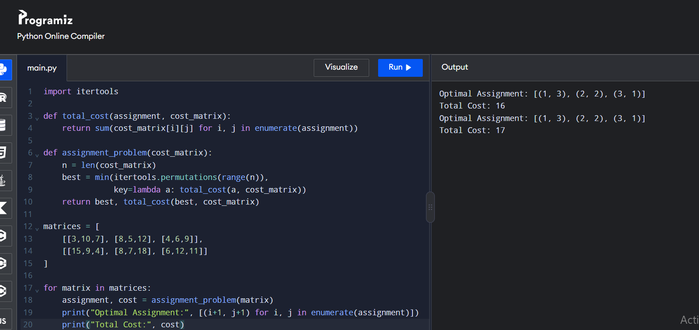
EX 29:
import itertools

def total_value(items, values):
return sum(values[i] for i in items)

def is_feasible(items, weights, capacity):
return sum(weights[i] for i in items) <= capacity

def knapsack(weights, values, capacity):
n = len(weights)
best_items, best_value = [], 0

for r in range(n + 1):
for items in itertools.combinations(range(n), r):
if is_feasible(items, weights, capacity):
value = total_value(items, values)
if value > best_value:
best_items, best_value = list(items), value

return best_items, best_value

print(knapsack([2,3,1], [4,5,3], 4))
print(knapsack([1,2,3,4], [2,4,6,3], 6))
OUTPUT:
